WALK, JOG OR RUN 10KM FOR COUNTRY DAYS!
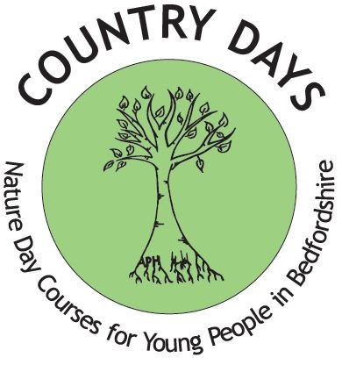

Country Days:
Nature day courses for young children in Bedfordshire

Register to take part in our 10km challenge on 6th December 2020
and help us raise money for Country Days.

REGISTRATION:
Follow the link to our Just Giving page on our website www.countrydays.net and make a payment of £5.00 to register. Email this completed form to info@countrydays.net

PERSONAL INFORMATION:

Name:
DOB:
Contact Information:
Address:
Postcode:
Mobile phone:
Email

Please tick box if you would like to have a Country Days tee-shirt to take part: Size
S ☐
M ☐
L ☐
XL ☐

We’d love to see your “Before” and “After” photos from your 10k challenge for our
fundraising page!
Please email your photos to us at: info@countrydays.net

Please ask your friends and family to sponsor you and follow our event on our social media pages on the website.
Thank you for taking part and have fun!

