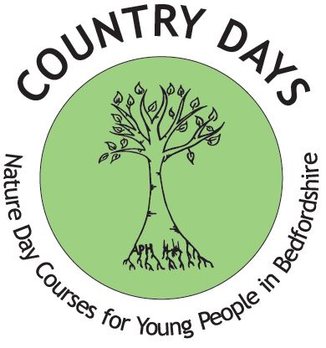
COUNTRY DAYS
Nature day courses for young people in Bedfordshire aged 7—11yrs
Become a Felmersham Fielder and find frogs, fresh air and freedom in our beautiful nature reserve!
COURSE DATES: -
Course 1: Monday 29th March and Tuesday 30th March
Course 2: Wednesday 31st March and Thursday 1st April
*Please note these courses repeat so choose one course only when booking
Time: 9.15am – 15.45pm each day.
FEE: £15.00 Transport included with pick up points in Kempston and Milton Ernest
FREE PLACES For entrants who receive free school meals or pupil premium

BOOKING FORM
NAME OF ENTRANT…………………………………………………………………………………….
ADDRESS OF ENTRANT…………………………………………………………………………………………..POSTCODE……………………………….
AGE OF ENTRANT ………………. DATE OF BIRTH…………………… SCHOOL ATTENDED…………………………………………………….

MALE FEMALE SCHOOL YEAR GROUP…………………………………………….

MEDICAL INFORMATION (please provide information regarding intolerances/allergies/ plaster allergy and other medical
issues we should be aware of)…………………………………………………………………………………………………………………………………………………
………………………………………………………………………………………………………………………………………………………………………………
PARENT/GUARDIAN NAME………………………………………………………………………………………………………………………………………
PARENT/GUARDIAN EMAIL …………………………………………………………………………………………………………………………………..
PARENT/GUARDIAN TEL.NO. ………………………………………………… MOBILE…………………………………………………
ADDRESS (if different from above) ……………………………………………………………………………………………………………………………..
PLEASE COMPLETE BELOW: -

I would like my Son/Daughter to attend the Country Days Course 1 (29th/30th Mar) Tick here
I would like my Son/Daughter to attend the Country Days Course 2 (31st Mar/1st Apr) Tick here

Please Note: -Parking and access to the field is limited, therefore we would appreciate it if you use the coach provided unless in the case of emergency. A coach will collect and drop off from the pickup points below: -
Please tick a Pick up point A) Kempston Hillgrounds Rd B) Milton Ernest Garden Centre

PLEASE READ CAREFULLY AND SIGN BELOW:-
*I give permission for my child to attend the Country Days course and to travel on the transport provided
* I give consent for my child receiving emergency medical aid if required during the course
*I will provide a packed lunch and drink * I will provide suitable clothing for the weather
* Sun cream & hat if hot (wellington boots/long sleeve top/long trousers)
* Extra layer if cold/Waterproof if raining * I will collect my child from the pick-up point indicated above

How did you find out about Country Days? ……………………………………………………………

I enclose the fee of £…………………. Cheques to be made payable to: Country Days Cash
BACS Payment Country Days limited sort code 40 01 22 account 81808680

I request a free place for my child as they receive free school meals………………. Pupil premium………………..
SIGNATURE Parent/Guardian ………………………………………………………………………. Date……………………………
Both sides of this form must be completed to register your child

Ethnic Origin

Which group does your child identify with? Please tick one box. The options are listed alphabetically.

 | Please tick one below |  | Please tick one below |  | Please tick one below
White- British |  | Mixed- Other |  | Black/ Black British-African
White- Irish |  | Asian/Asian British- Indian |  | Black/ Black British-Other
White- Other |  | Asian/Asian British- Pakistani |  | Chinese
Mixed- White and Black Caribbean |  | Asian/Asian British- Bangledeshi |  | Any other Ethnic group
Mixed- White and Black African |  | Asian/Asian British- Other |  | Not stated

RETURN TO:- Post: PO Box 1591, Bedford, MK42 5DT , Email: info@countrydays.net ,Tel: 07599336532 or 07938267057, Facebook: https://www.facebook.com/Countrydays1

Your booking will be confirmed ASAP………1st come 1st served.
In line with GDPR please tick one of the following
I consent for Country Days to retain my information and use for marketing purposes.
I do not consent for Country Days to retain my information and use for marketing purposes.

I give permission for images of my child to be used for Country Days promotional material including facebook and the website YES……….NO……….

Please go to www.countrydays.net to see our Privacy Notice.
Registered Charity Number 1181833
Any cancellations no refund will be given after Monday 3rd August

