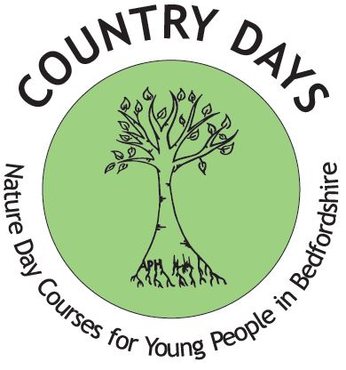
COUNTRY DAYS
Nature day courses for young people in Bedfordshire aged 7—11yrs
Become a Felmersham Fielder and find frogs, fresh air and freedom in our beautiful nature reserve!
Easter COURSE DATES: -
Course 1: Monday 29th March and Tuesday 30th March*
Course 2: Wednesday 31st March and Thursday 1st April*

Registered Charity Number 1181833

Summer COURSE DATES: -
Course 1: Tuesday 10th & Wednesday 11th August
Course 2: Thursday 12th & Friday 13th August

*Please note the Easter courses repeat so choose one course only when booking
Time: 10am – 2:30pm each day.
FEE: £15.00 Must provide own transport
FREE PLACES For entrants who receive free school meals or pupil premium
If you sign up for two courses, the price is discounted to £25 total.

BOOKING FORM
NAME OF ENTRANT…………………………………………………………………………………….
ADDRESS OF ENTRANT…………………………………………………………………………………………..POSTCODE……………………………….
AGE OF ENTRANT ………………. DATE OF BIRTH…………………… SCHOOL ATTENDED…………………………………………………….

MALE FEMALE SCHOOL YEAR GROUP…………………………………………….

MEDICAL INFORMATION (please provide information regarding intolerances/allergies/ plaster allergy and other medical
issues we should be aware of)…………………………………………………………………………………………………………………………………………………
………………………………………………………………………………………………………………………………………………………………………………
PARENT/GUARDIAN NAME………………………………………………………………………………………………………………………………………
PARENT/GUARDIAN EMAIL …………………………………………………………………………………………………………………………………..
PARENT/GUARDIAN TEL.NO. ………………………………………………… MOBILE…………………………………………………
ADDRESS (if different from above) ……………………………………………………………………………………………………………………………..

PLEASE COMPLETE BELOW: -
I would like my Son/Daughter to attend the Country Days Easter Course 1 (29th/30th Mar) Tick here

I would like my Son/Daughter to attend the Country Days Easter Course 2 (31st Mar/1st Apr) Tick here

I would like my Son/Daughter to attend the Country Days Summer Course 1 (10th/11th Aug) Tick here
I would like my Son/Daughter to attend the Country Days Summer Course 2 (12st Aug/13th Aug) Tick here

PLEASE READ CAREFULLY AND SIGN BELOW:-
* Sanitiser will be provided
* I give consent for my child receiving emergency medical aid if required during the course
*I will provide a break time snack, lunch and drink
* I will provide suitable clothing for the weather
* Sun cream & hat if hot (wellington boots/long sleeve top/long trousers)
* Extra layer if cold/Waterproof if raining

How did you find out about Country Days? ……………………………………………………………

I enclose the fee of £…………………. Cheques to be made payable to: Country Days Cash

BACS Payment Country Days limited sort code 40 01 22 account 81808680

I request a free place for my child as they receive free school meals………………. Pupil premium………………..
SIGNATURE Parent/Carer ………………………………………………………………………. Date……………………………
Both sides of this form must be completed to register your child

Ethnic Origin
Which group does your child identify with? Please tick one box. The options are listed alphabetically.

 | Please tick one below |  | Please tick one below |  | Please tick one below
White- British |  | Mixed- Other |  | Black/ Black British-African
White- Irish |  | Asian/Asian British- Indian |  | Black/ Black British-Other
White- Other |  | Asian/Asian British- Pakistani |  | Chinese
Mixed- White and Black Caribbean |  | Asian/Asian British- Bangledeshi |  | Any other Ethnic group
Mixed- White and Black African |  | Asian/Asian British- Other |  | Not stated

RETURN BY Post: PO Box 1591, Bedford, MK42 5DT OR Email: info@countrydays.net
Contact us by telephone on 07599336532 or 07938267057 and visit our website for more information: www.countrydays.net

Your booking will be confirmed ASAP, 1st come 1st served!
In line with GDPR please tick one of the following:
I consent for Country Days to retain my information and use for marketing purposes. YES NO

I give permission for my details to be added to the Country Days mailing list. YES NO

I give permission for images of my child to be used for Country Days promotional material including on social media and the website. YES NO

Please go to www.countrydays.net to see our Privacy Notice.

